Lowther Medical Centre
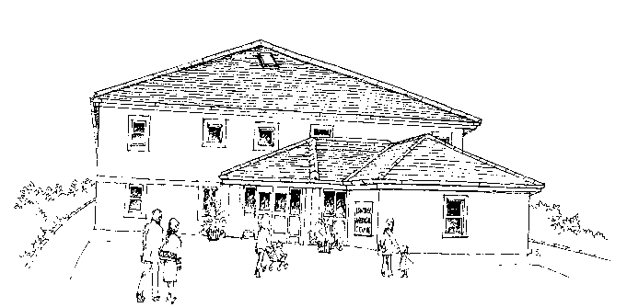

Complaints and Concerns

We work hard to improve access to our service and all our staff are committed to providing the highest standard of patient care. We understand there may be times however when you have cause for concern and we wish to share with you some recent concerns and action taken.

….You said: You were fed up of waiting in the telephone queue only to find out all the GP/NP appointments for the day had been booked

We did: Our Reception team now activate an automatic telephone message on a daily basis when the on the day GP and NP slots have all been booked

Compliments

We are pleased to share with you recent compliments received by the Practice.

“I got an appointment easily through MyGP app. My appt was on time and the Trainee Dr was very good”

“They have been excellent throughout my treatment, everyone has been great”
“Seen on time, organised Shingles vaccination and next blood test appointment as well as asthma review”

