Lowther Medical Centre
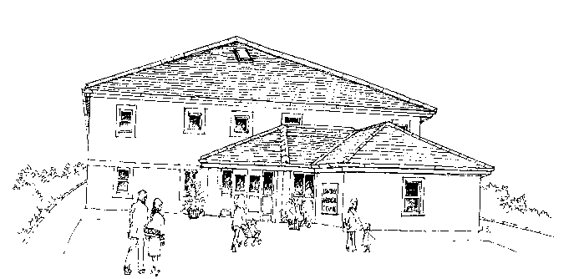

Complaints and Concerns

We are working hard to improve access to our service and all our staff are committed to providing the highest standard of patient care.

We understand there may be times however when you have cause for concern and we wish to share with you some recent concerns and our actions

….You said: You found it difficult to book appointments by telephone

We did: As well as Bloods, Smears, Telephone Contraception advice appointments available to book online via MyGP and Patient Access, patients can also complete an Online consult form for non-urgent conditions which will be triaged by our Clinical team. You can access the form via the Home page of our website.
Compliments

We are pleased to share with you recent compliments received by the Practice.

“Helpful receptionist. The Medical practitioner rang on time arranged a one to one and dealt with my problem in a pleasant professional manner”

“The Practice is so friendly, helpful, caring and supporting”

“The Dr rang me back even though I missed her first call. She was friendly and helpful”

