Lowther Medical Centre
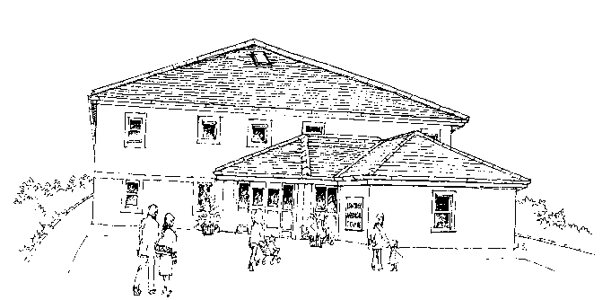

Complaints, Compliments, Concerns and Comments

Lowther Medical Centre
1 Castle Meadows
Whitehaven
Cumbria
CA28 7RG

Tel: 01946 692241
Fax: 01946 592611

Website – www.lowthermedical.co.uk

Our aim is to provide the highest standard of care for all our patients. We are always willing to hear if there is any way that you think that we can improve the service we provide. We welcome comments or suggestions that can help us to do so – good or bad! To provide feedback, please leave your comments in the Suggestions Box located in the Reception Foyer.

Making a complaint
We understand there may be times when you have more serious cause for concern regarding the service provided and wish to make a complaint.

We hope that most problems can be sorted out easily and quickly, often at the time they arise and with the person concerned. If you are not able to resolve your complaint in this way and you wish to make a formal complaint you should do so, preferably in writing as soon as possible after the event and ideally within a few days, as this helps us to establish what happened more easily. If it is not possible to do that, please let us have details of your complaint:
- Within 6 months of the incident that caused the problem
or
- Within 6 months of discovering that you have a problem, provided that is within 12 months of the incident

Our Site Manager will be pleased to deal with any complaint or concern. She will explain the procedure to you and make sure that your concerns are dealt with promptly.

You can make your complaint:
- In person – Please ask to speak to the Site Manager
or
- In writing - Some complaints may be easier to explain in writing. Please provide as much information as possible and send your complaint to the Practice marked “For the Attention of the Site Manager”

What we shall do
Our complaints procedure is designed to make sure that we settle any complaints as quickly as possible.

We shall acknowledge your complaint within 3 working days and aim to have looked into your complaint within 10 working days of the date when you raised it with us. We shall then be in a position to offer you an explanation, or a meeting with the people involved. If the matter is likely to take longer than this we will let you know, and keep you informed as the investigation progresses.

When we look into your complaint we shall aim to:
- Find out what happened and what went wrong
- Make it possible for you to discuss the problem with those concerned, if you would like this
- Make sure you receive an apology, where appropriate
- Identify what we can do to make sure the problem does not happen again

At the end of the investigation your complaint will be discussed with you in detail, either in person or in writing.

Complaining on behalf of someone else
Please note that we keep strictly to the rules of medical confidentiality. If you are complaining on behalf of someone else, we have to confirm that you have his or her permission to do so. A note signed by the person concerned will be needed, unless they are incapable (due to illness) of providing this.

What you can do next
We hope that, if you have a problem, you will use our Practice Complaints Procedure. We believe that this will give us the best chance of putting things right and improving our service in the Practice.

However, this does not affect your right to approach NHS England if you feel you cannot raise your complaint with us or you are dissatisfied with the way we are dealing with your complaint:
NHS England
P.O.Box 16738
Redditch
B97 9PT
Tel no 0300 3112233
Email - England.contactus@nhs.net

If you require independent advice, advocacy or support, you may contact:
Healthwatch Cumbria, Head Office, 4-6 Oxford Street, Workington, Cumbria CA14 2AH
Tel: 0300 303 8567
Email: infor@healthwatchcumbria.co.uk
Website: www.healthwatch.co.uk/directory/cumbria

If you feel that we have not responded to your complaint fully, then the matter can be referred to the Health Service Ombudsman:
The Parliamentary and Health Service Ombudsman
3 New York Street
Manchester
M1 4HN
Tel: 0345 015 4033
Website: www.ombudsman.org.uk

If you remain dissatisfied with the response to your complaint, you also have the right to ask the CQC to review your case. The Care Quality Commission is an independent body established to promote improvements in healthcare through the assessment of the performance of those who provide service. You can contact them on:
Care Quality Commission
Tel: 03000 616161
Email: enquiries@cqc.org.uk
Website: www.cqc.org.uk

Help us get it right
We constantly try to improve the service we offer. Please let us know when you think we have done something well or if you have any suggestions as to how we can do something better.

Patients should be assured they will not be treated any differently should they raise a concern and that we use these anonymised reviews to learn from. Please do let us know if we have fallen short of your expectations as we would like to get this right for you.

Notes

This Leaflet is also available in large print – please ask Reception for a copy

